**LAB 4**

**4.1 Write a program determine whether the input number is even or odd**

**SOURCE CODE**

**#include <iostream>**

**using namespace std;**

**int main()**

**{**

**int a;**

**cout<<"Enter a number \n";**

**cin>>a;**

**if(a%2==0)**

**cout<<a<<" is an even number"<<endl;**

**else**

**cout<<a<<" is an odd number"<<endl;**

**return 0;**

**}**

**OUTPUT**

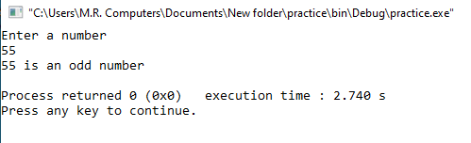

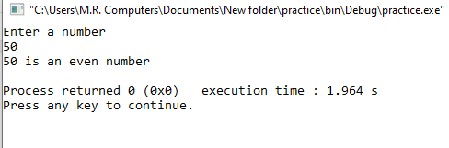

**4.2 Write a program to perform above task using switch case.**

**SOURCE CODE**

**#include <iostream>**

**using namespace std;**

**int main ()**

**{**

**int i, j, operation, operations;**

**cout<<"Enter a number \n";**

**cin>>i;**

**j=i%2;**

**cout<<j<<endl;**

**operation=j;**

**switch(operation)**

**{**

**case 0:**

**cout<<i<<" is an even number";**

**break;**

**default:**

**cout<<i<< " is an odd number";**

**}**

**return 0;**

**}**

**OUTPUT**

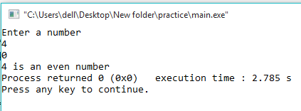

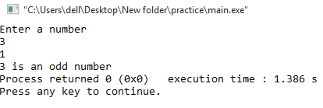

**4.3 write a program to generate a mark sheet which shows obtained marks, average and grade by using if else condition.**

**SOURCE CODE**

**#include <iostream>**

**using namespace std;**

**int main ()**

**{**

**int a,b,c,d,e,percentage,sum;**

**cout<<"Enter marks of 1st subject"<<endl;**

**cin>>a;**

**cout<<"Enter marks of 2nd subject"<<endl;**

**cin>>b;**

**cout<<"Enter marks of 3rd subject"<<endl;**

**cin>>c;**

**cout<<"Enter marks of 4th subject"<<endl;**

**cin>>d;**

**cout<<"Enter marks of 5th subject"<<endl;**

**cin>>e;**

**sum=a+b+c+d+e;**

**percentage=sum/5;**

**cout<<"\nTotal marks obtained by the student is "<<sum<<" out of 500\n"<<endl;**

**cout<<"Percentage of the student is "<<percentage<<"%\n"<<endl;**

**if (percentage>=90&&percentage<=100)**

**cout<<"Student has been awarded A grade"<<endl;**

**else if (percentage>=80&&percentage<=89)**

**cout<<"Student has been awarded B grade"<<endl;**

**else if (percentage>=70&&percentage<=79)**

**cout<<"Student has been awarded C grade"<<endl;**

**else if (percentage>=60&&percentage<=69)**

**cout<<"Student has been awarded D grade"<<endl;**

**else if (percentage>=50&&percentage<=59)**

**cout<<"Student has been awarded E grade"<<endl;**

**else if (percentage<50)**

**cout<<"Student has been awarded F grade"<<endl;**

**return 0;**

**}**

**OUTPUT**

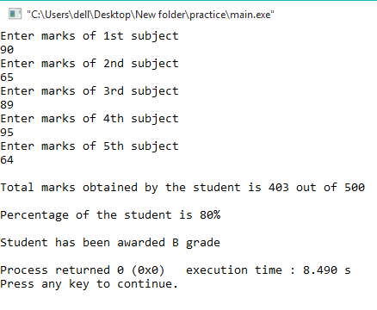

**4.4 Write a program to detect whether the input character is an UPPER CASE letter or LOWER CASE or if it is a SPECIAL CHARACTER**

**SOURCE CODE**

**#include <iostream>**

**using namespace std;**

**int main()**

**{**

**char a, lowercaseletter, UPPERCASELETTER, specialcharacters;**

**cout << "Enter a Character" << endl;**

**cin>>a;**

**lowercaseletter = (a=='a' || a=='b' || a=='c' || a=='d' || a=='e' || a=='f' || a=='g' || a=='h' || a=='i' || a=='j' || a=='k' || a=='l' || a=='m' || a=='n' || a=='o' || a=='p' || a=='q' || a=='r' || a=='s' || a=='t' || a=='u' || a=='v' || a=='w' || a=='x' || a=='y' || a=='z');**

**UPPERCASELETTER = (a=='A' || a=='B' || a=='C' || a=='D' || a=='E' || a=='F' || a=='G' || a=='H' || a=='I' || a=='J' || a=='K' || a=='L' || a=='M' || a=='N' || a=='O' || a=='P' || a=='Q' || a=='R' || a=='S' || a=='T' || a=='U' || a=='V' || a=='W' || a=='X' || a=='Y' || a=='Z');**

**specialcharacters = (a=='!' || a=='@' || a=='#' || a=='$' || a=='%' || a=='^' || a=='&' || a=='*' || a=='(' || a==')' || a=='_' || a=='-' || a=='=' || a=='+' || a=='|' || a=='[' || a==']' || a=='{' || a=='}' || a==';' || a=='"' || a==':' || a=='/' || a=='?' || a=='.' || a==','|| a=='<' || a=='>' || a=='/' || a=='*' || a=='-');**

**//NOT INCLUDED SPECIAL CHARACTERS ' and \ only**

**if (lowercaseletter)**

**cout<<a<<" is a lowercase letter"<<endl;**

**else if(UPPERCASELETTER)**

**cout<<a<<" is a uppercase letter"<<endl;**

**else if(specialcharacters)**

**cout<<a<<" is a special character"<<endl;**

**else**

**cout<<a<<" is an invalid character"<<endl;**

**return 0;**

**}**

**OUTPUT**

